Bill Mc Bride

Bill McBride has worked in a variety of public school and university settings. In middle and secondary schools, he has served as a Reading Specialist, English and Social Studies teacher, Drama teacher, and Gifted and Talented instructor. On the university level, Bill assisted in the training and evaluation of middle and secondary Language Arts interns. He holds a Masters in Reading and a Ph.D. in Curriculum and Instruction from the University of North Carolina at Chapel Hill.

Keynote
Helping All Learners Connect to and Comprehend Media
An Engaging workshop to show how to teach media literacy to all students. Learn how to help students do “close reads” of media to analyze its methods and message.
Breakout Session
Engaging the Disengaged: Involving All Learners in the Classroom
Highly engaging workshop will show how the interactive characteristics of technology capture students’ attention can be incorporated into all types of classroom strategies.
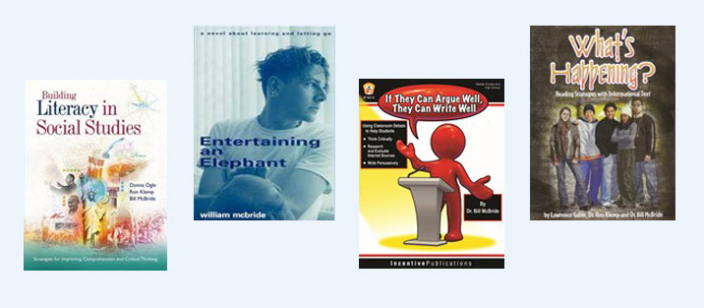
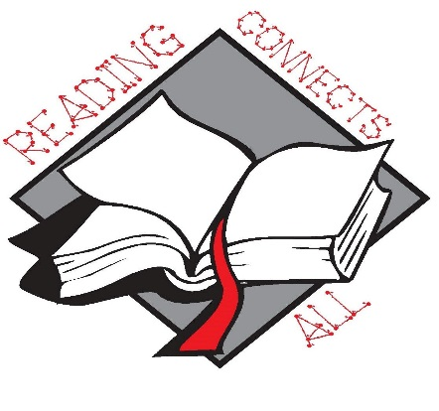

West Virginia Reading Association
60th Annual Conference
November 19-20, 2015

The Greenbrier Resort White Sulphur Springs, West Virginia

